

|  |  |  |
| --- | --- | --- |
| Class: **III/IV B.Tech** | **I Mid-term Examinations** | Date :28/11/2020 |
| Branch: **ECE** | **LINEAR CONTROL SYSTEMS** | Time :**90 Min** |
| Sub Code: **EC-311** |  | Max. Marks :**18** |

**SECTION-A**

**Answer All Questions: (6 x 1 = 6M)**

1. a) Define system, control system. (PO 6, 7) (CO 1) **(Understand)**

b) Distinguish between linear and nonlinear control system. (PO 6, 7) (CO 1, 2, 5) **(Understand)**

c) State disadvantages and advantages of signal flow graph. (PO 1, 6, 7) (CO 1, 5) **(Understand)**

d) What are the standard test signals? (PO 1, 6, 7) (CO 1, 5) **(Understand)**

e) Define the term raise time, settling time. (PO 1, 6, 7) (CO 1) **(Understand)**

f) Define steady state response and steady error (PO 1, 6, 7) (CO 1, 2, 5) **(Understand)**

**SECTION-B (1x 6 = 6M)**

1. a) Draw the signal flow graph and derive the transfer function of the system using mason’s gain formula. (PO 1,6,7,12) (CO 1) **(Apply)**

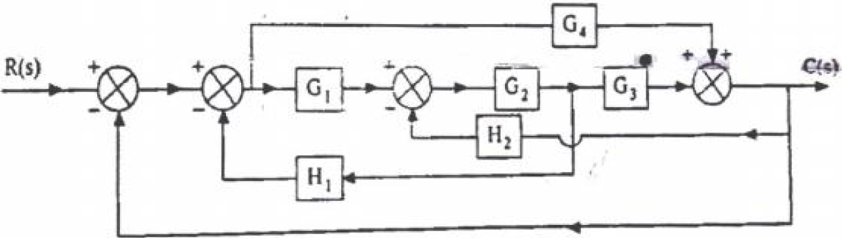

b) Obtain the transfer function Armature controlled DC motor.

**(OR)**

1. a) Write the differential equations for mechanical system shown in figure and obtain an analogous electrical circuit in force-voltage analogy. (PO 1,6,7,12) (CO 1) (**Understand)**

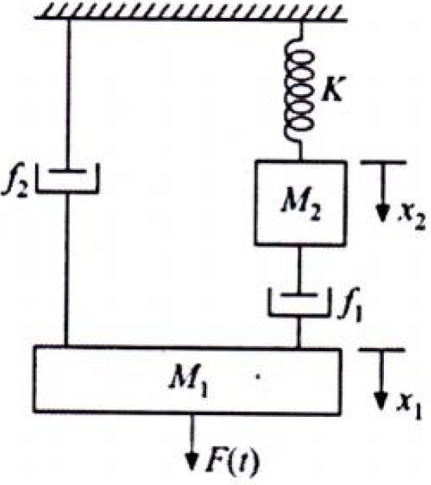

b) Explain the working principle of synchro transmitter.

**SECTION-C (1 x 6 = 6M)**

1. a) Write the expression for time domain specification of a second order control system and indicate with neat sketch? Also how damping ratio affect the time response of second order system. (PO 1,6,7) (CO 2) **(Understand)**

b) Determine the range of K for stability .

**(OR)**

1. a) Determine the stability of system represented by the characteristic equation  by means of Routh criterion. (PO 1,6,7) (CO 1,2,3) **(Understand).**

b) Determine the step, ramp and parabolic error constant for the following system with unity feedback.

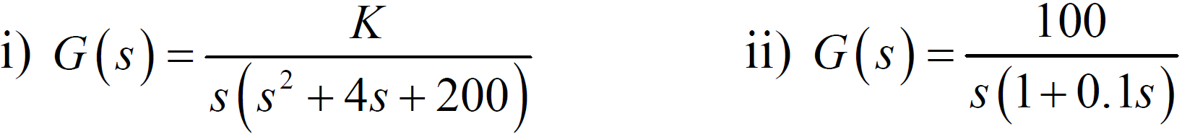

Signature of Faculty

(Mr.G.Satish)